Date:27th-July-2021 **Financial Analysis Dashboard**

**Aim of Assignment:**  
You need to create a Financial Analysis Dashboard in Power BI desktop (in given PBIX file) as shown in the reference PDF provided.

**Understanding the data:**  
The given PBIX file contains 7 tables as below.

1. Projects - Contains project related data
2. Invoices – Contains Invoices for project
3. Members – Contains Employee data
4. Expenses – Contains Project Expense data
5. Products – Contains Product purchased during project
6. Time Entries – Contains time spent by members on any task while working on project
7. Cost to Date – Supporting table for Pie chart.

**Data Model:**.   
1. Create a calendar table.  
2. Establish below relationships between tables.  
 1. Create relationship between Project and Expense table on Project.ID and Expenses.ProjectID   
 2. Create relationship between Project and Invoices table on Project.ID and Invoices.ProjectID  
 3. Create relationship between Project and Time Entries table on Project.ID and TimeEntires.ProjectID  
 4. Create relationship between Project and Products table on Project.ID and Products.ProjectID  
 5. Create relationship between Calendar and Expense table on Calendar.Date and Expenses.Date  
 6. Create relationship between Calendar and Invoices table on Calendar.Date and Invoices.Date  
 7. Create relationship between Calendar and Products table on Calendar.Date and Products.PurchaseDate  
 8. Create relationship between Calendar and TimeEntries table on Calendar.Date and TimeEntries.TimeEnd  
 9. Create relationship between Members and TimeEntries table on Members.ID and TimeEntries.Member.id  
  
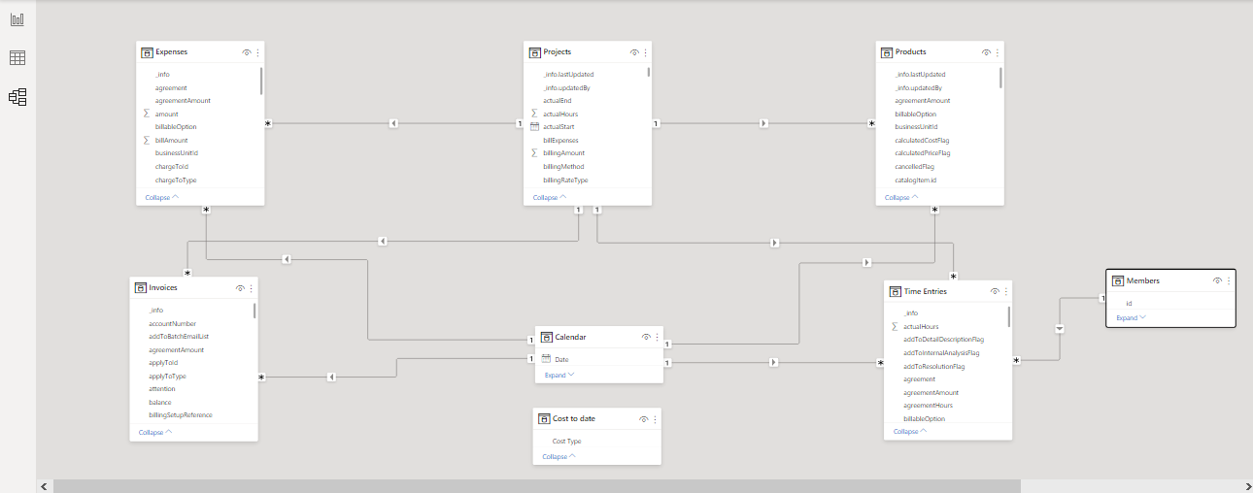  
  
**Dashboard Requirements:**Below are certain requirements, which you need to take in consideration while designing dashboard.

1. Design neat and clean dashboard as shown in reference file and all values should match with as shown in screenshots.
2. Dashboard should only represent data for projects which has started after 1St Jan 2020. (There are couple of ongoing projects which has started before 2020, you need to exclude data for those projects from dashboard.)
3. Year slicer on top should filter data in respective selected year.   
   E.g. – If, 2021 is selected in slicer, then visuals should represent 2021 data only. If project has started in 2020, but it has some invoices, purchases, etc in 2021, then those entries should be considered in the 2021.

**Understanding Dashboard and KPIs**:  
  
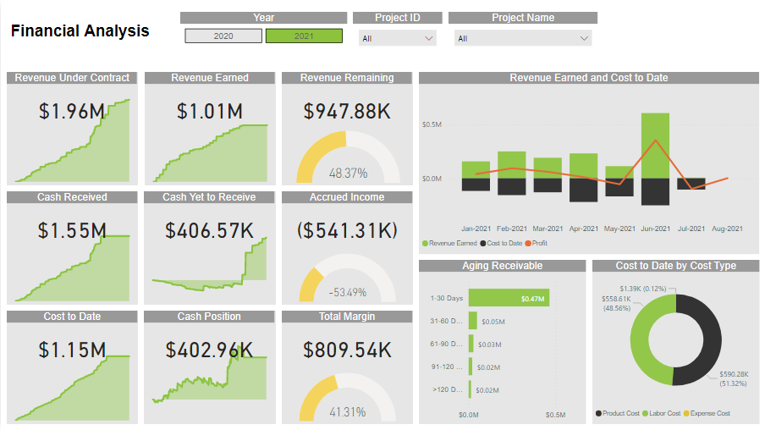  
 **1. Revenue Under Contract:** This is the total estimated amount of the project, and the client has agreed to pay this much amount for the project. This can be easily calculated from the Invoices data where invoice type = DownPayment*. (Invoices.Total where Invoices.Type= DownPayment)*  
  
**2. Revenue that has been ‘Earned’:** This is the amount of which work has been done.This KPI can be calculated from the Payment Applied column in the Invoices data. (*Invoices.DownPayment_Applied*)  
  
**3**. **The total remaining Revenue:** This is the amount for future work of the same project. This amount can be calculated by doing subtraction of Revenue under Contract and Revenue that has been earned (*1-2*)  
  
***% total remaining Revenue*** *= (Revenue Under Contract – Revenue that has been Earned)/ Revenue Under Contract*  
  
**4. The total Cash paid to date (Cash Received):** This is the amount we received to date from the client. We can easily calculate this amount from Payment column in the Invoice’s data. (*Invoices.Payments*)  
  
**5. Cash yet to Receive:** This is the amount we will receive from client in the future. We can calculate this amount by subtracting Cash paid to date from Revenue under contract. (*1-4*)

**6. Accrued Income:** This amount is nothing but the subtraction of Amount that has we received and the amount that has been earned. (*2-4*)  
  
***%Accrued Income*** *= (Revenue that has been earned - Cash Received)/ Revenue that has been earned*  
  
**7. The total Project Cost to date:** This is the total amount of expenses we have done on the project. This amount is sum of Labour cost, Product cost, and Expenses. (*LaborAmount + Expenses.Amount + Product.ExtCost*)  
 *1. Labour Amount = Member.HourlyCost*TimeEntries.actualHours  
 2. Product.ExtCost = If Products.CancelledFlag=’False’ or 0 then Product.Cost*Product.Quantity else 0*  
**8.** **Current cash position:** This amount is nothing but the subtraction of Total project cost to date from Total cash paid to date (*4-7*).  
  
**9. Total Margin:** This amount is net amount remaining after all the expenses have been done. This can be calculated by subtracting Project cost to date amount from revenue under contract amount *(1-8)*   
  
***% Total Margin*** *= (Revenue Under Contract – Current cash position)/ Revenue Under Contract***10. Profit:** This is nothing but subtraction of Project Cost to date from Cash Received. (*4-7*)

**Understanding Visuals:**  
 1.CARD + Area Chart   
 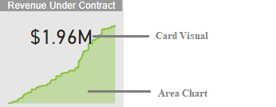As shown in above screenshot these are two different visuals. You need to arrange and format these two visuals to achieve above results.   
Area chart is cumulative YTD chart.  
  
2. CARD + Gauge Chart 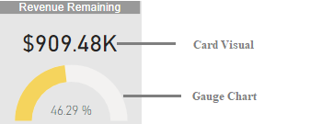

As shown in above screenshot these are two different visuals. You need to arrange and format these two visuals to achieve above results.

3. Line and Stacked column chart -*Hint: To design this visual you need to convert ‘Cost to Date’ values to Negative values*.

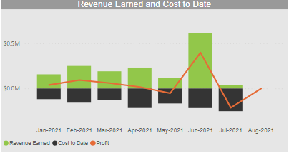4. Aging Receivables **-**You can find more about Receivables Aging [here](https://www.investopedia.com/terms/a/accounts-receivable-aging.asp#:~:text=Accounts%20receivable%20aging%20(tabulated%20via,health%20of%20a%20company's%20customers.). To design this chart, you need to calculate age of an invoice on 27th July-2021.   
Invoice Age = (27th July 2021 – Invoice due date)   
You need to consider only those invoices for which Invoice.Type=DownPayment **and** (Invoice.Payments=0 **or** blank)

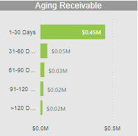

5. Cost to Date by cost type:   
*Hint: To design this chart you need to use ‘Cost Type’ column available in the ‘Cost to date’ table.*

